Title of Improvement Project

Identified Project Sponsor

Initiative Start Date

Initiative End Date

Location of Project

Improvement Team Names & Titles

ARECCI Project Ethics Score & Notes
Identified Need or Opportunity for Patient Participation
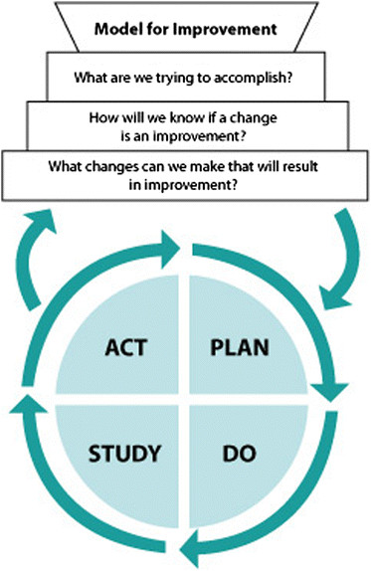

PROJECT PROPOSAL

What are we trying to accomplish?
Problem Statement | It’s important to work on this now because….
Aim Statement | What will improve? Where? By how much? By when?
Business Case | Outline improvements in productivity, patient & provider satisfaction, cost savings associated with the project.

PROJECT INITIATION

Project Scope
Where does the project begin and end? What work will this project include/not include?

Risks & Mitigations
What are the risks for participants/organization?
How can you mitigate these risks?
How will the benefits of the project outweigh the remaining risk?

PROJECT PLANNING

MEASUREMENT PLAN: How will we know that a change is an improvement?
MeasureS | Baseline | Target | Plan to Collect Data  (how will it be collected, frequency of collection & who will collect it, etc)
OUTCOME MEASURE(S)
PROCESS MEASURE(S)
BALANCING MEASURE(S)

TEAM ROLES
NaMe &title | role on the team  (List duties/responsibilities the team member will perform for the team)  i.e. data collection, run PDSAs, etc

COMMUNICATION PLAN: Who needs to know about your project?
AUDIENCE(s) | KEY MESSAGE | cOMMUNICATION cHANNEL(S)  (email, posters, social media, etc) | TIMELINE AROUND COMMUNIcATION | wHO WILL TAKE ON COMMUNICATION ROLES  (Creating communication, getting NH communication approval, sending communication)

TESTS OF CHANGE

What changes can we make that will result in improvement?
Identify your process changes ideas.

Initial Activities
i.e. collecting baseline data, process mapping, creating education materials, educate physicians and nurses on the unit

PDSA
PDSAs trialled

