ARECCI
- acronym created by Alberta Innovates-Health Solutions
- stands for “A pRoject Ethics Community Consensus Initiative”
Ethical issues exist in non-research projects and should be considered at all stages of a project and managed within the organizational context. ARECCI is a simple online tool that allows exploration of potential ethical issues when doing QI work.
ARECCI
- provides a framework and explores the key ethical principles of :
  - respect for human dignity
  - Free and informed consent
  - Vulnerable persons
  - Privacy and confidentiality
  - Justice and inclusiveness
  - Balance of harms and benefits
http://www.aihealthsolutions.ca/arecci/screening/451605/7da9ecf8cb2c67e4aa4a36e608b5ca3a
ARECCI tool can be accessed at:
http://www.aihealthsolutions.ca/arecci/screening

Once you are finished the survey you will get a score. The scores are as follows:
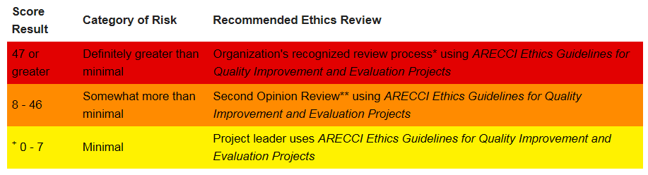
If your score is 7 or under, you are good to go. Nothing further is required.
If your score is between 8 and 46, there is no reason to panic. Speak with your PQI Coach and she can help arrange a second reviewer for you. This process usually doesn’t take long and likely the project can still go ahead.
If you score 47 and above, speak with your PQI Coach, there are likely some revisions needed to the way your project is designed.

